**Names of Student_____Yixin Wang________________ Student ID____yw326______**

**EE 188L: Lab 7**

**2-stage Operational Amplifier Circuits**

**NAU + CQUPT (Fall 2020)**

1. **Please work in a team of 2 students for this lab. You can each submit the same report into Bblearn, but do it separately.**
2. **Introduction**

The **basic properties** of the **ideal op-amp** have been introduced and discussed in class, along with **additional details and results** of those basic properties.

As explained in class the **ports** and **properties** of the **ideal op-amp** are:

* ***vp =*> noninverting input** with respect to ground.
* ***vn* => inverting input** with respect to ground.
* ***vd* = *vp - vn* => difference input voltage** (Note: **not** with respect to ground).
* ***vo* => output** with respect to ground.
* **Rin = ∞ => input resistance between *vp*** and ***vn;*** this results that the **currents** into the **input ports *i+* & *i-* = 0**.
* **Rout = 0 => output resistance** at the ***vo* port**

The **Rin & Rout** values**🡪 no loading** at the **inputs** or **output**.

* **Avo = ∞ with infinite bandwidth (BW)**
* **No offset output voltage🡪** if ***vd,* *vp* &** ***vn* all = 0**, then ***vo* = 0**
* the presence of an **external negative feedback path**.

In **Lab 6** you became familiar with the use and characteristics of a 741 op-amp as an ideal op-amp, by building and testing the following circuits:

• Inverting Amplifier

• Non-inverting Amplifier

• Inverting & Summing Amplifier

* Difference Amplifier

In this Lab (Lab 7), the experiment is to design a 2-stage cascaded op amplifier circuit that has the following specifications:

* 2 stages in cascade (output of stage 1 is the input of stage 2).
* Inverted output
* Total Gain Gv = **-18** (volt/volt). (Remember: total Gain Gv = G1*G2)!
* Use a 100Hz sine wave voltage signal rom the lab Function generator to demonstrate gain achieved

Build the system on the BB and test it. Each team must show the waveforms on the oscilloscope to the Instructor before leaving!

**MATERIALS:**

1. two 741 Op-Amp or LM 308 Op-Amp (note identical pinouts)

2. Assorted Resistors

3. Function Generator

4. Digital Multimeter

5. Dual Channel Oscilloscope

6. Multiple output DC Power Supply

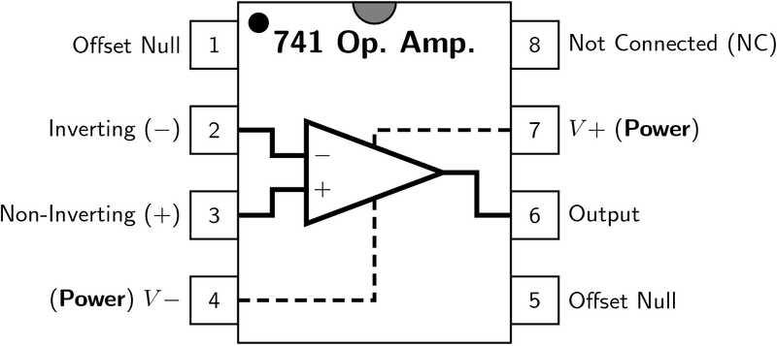

**PROCEDURE:**

1. **Design:** First, decide what gain you wish to get from each of the two amplifier stages. One of the stages will have to be a -ve gain. Review the formulas for gain of various op-amp amplifier types. Then, select appropriate resistor values (R1, R2, R3, R4) to use for each stage to achieve these gains. Make sure your resistor values are actually available in your lab for you to do the experiment.
2. Connect the circuit as shown
3. Use +/- 15 volts for the Op-Amp DC voltages on pins 7 & 4.
4. Use a value between **10 mV – 100 mV** (100Hz)ac as the input signal vin, not DC
5. Test each stage separately first to make sure it works!

——————————————



Example connection for a Cascaded 2-stage Amplifier. You can **change the order** of the inverting & non-inverting stages, if you wish.

For reference, the circuits of Lab 6 are shown below. Your task is to design a 2-stage system using both the circuits shown below.

1. **Inverting Amplifier**

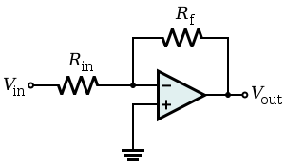

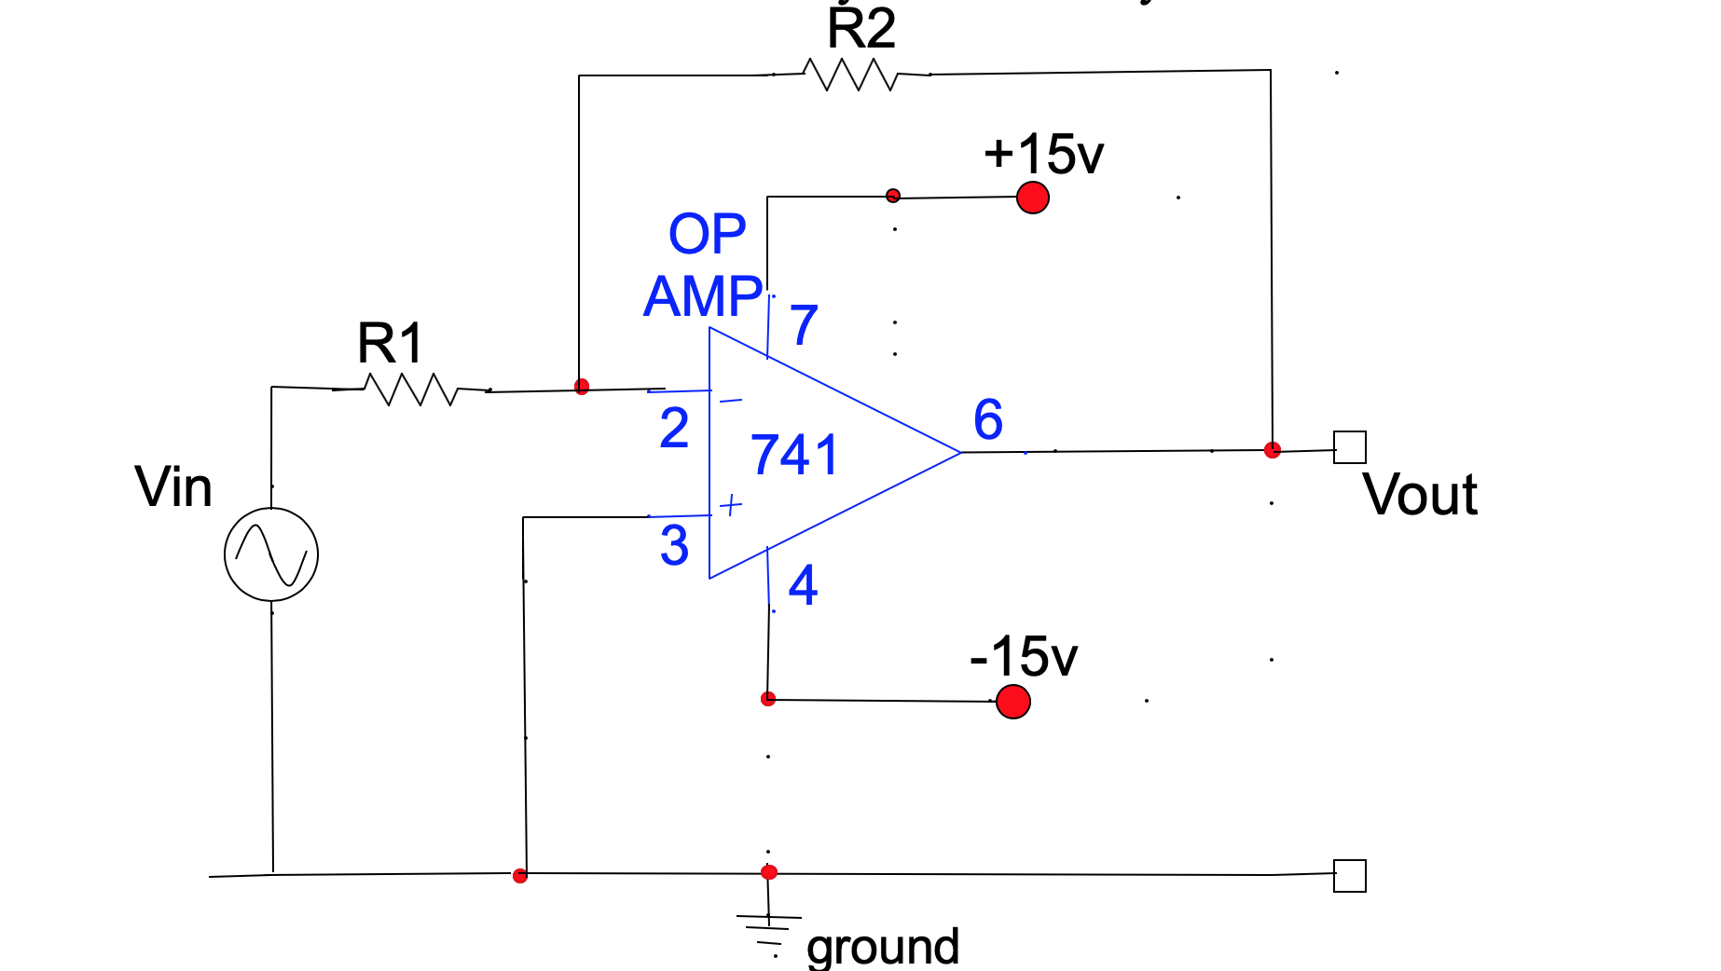

**Example connections for an Inverting Amplifier**

1. **Noninverting Amplifier**

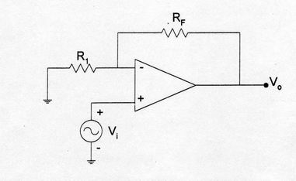

**Results:**

1. Signature: Each team **must** **show** the waveforms on the oscilloscope to the instructor and get his/her signature.

Instructor Signature : _________________________ Date: ____________

2. Graph:Draw the 3 waveforms of your amplifier system below one another on the graph paper below. Show: vin, vout1 for stage 1, and vout2 for stage 2. (Include the time scale and voltage scale for each waveform).



(Use pencils and please **BE NEAT!)**

**The three waveforms: *vin,* *vout1, & vout2***

